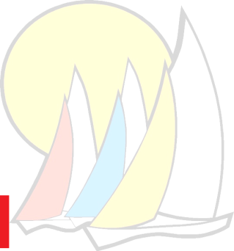
Cowpet Bay West
6201 Windward Way, St. Thomas, USVI 00802
Phone: 340-775-6675/Fax: 340-779-6407
E-Mail: cowpetbaywest@hotmail.com

2026 Cowpet Bay West Board Members
Roman Viere, President Sherri Levin
Cell: (773) 406-8763 Cell: (410) 562-5629
Email: rlviere@ua4rent.com Email: stthomasparadise@gmail.com
Unit Number: W-05 Unit Numbers: W-10,W-40, L-41
Judi Kromenhoek, Secretary George Hefferon, Treasurer Cell:(340) 677-3267 Cell: (914) 763-9176
Email: jkromes@gmail.com Email: cbw21gjh@gmail.com
Unit Number: W-42, W-44 Unit Number: W-21
Michael Harrell William Brewer
Cell: (703) 927-5629 Cell: (304) 276-9977
Email: mrh.llc@verizon.net Email: wbrewer@brewerlaw.com
Unit Number: L-24 Unit Number: L-42
Rosie Wells Richard Hunter, Vice President
Cell: (340) 227-6691 Cell: (340) 690-1199
Email: wellsr_@earthlink.net Email: rhuntercowpet@gmail.com
Unit Number: L-37 Unit Number: L-49
Jim Tometich
Cell: (515) 291-1221
Email: jet@tometichengineering.com
Unit Number: L-44

