2024 Cowpet Bay West Annual Owner’s Meeting
February 17, 2024
Call to order: The Annual Owner’s Meeting was called to order by President Bill Hanson at 9:15am at the Caribbean Fish Market. The meeting was also held via ZOOM. Board members present were Bill Hanson, Mike Harrell, Richard Hunter Kevin Gregory, Judi Kromenhoek, Sherri Levin, and Marilyn Blackhall. Matthew Willey, Property Manager, and Tanji Williams, Office Manager were also present.
Roll Call: Owners were directed to sign in upon arrival. Owners were asked to identify themselves as their names were called, and asked to give their unit numbers. Owners on Zoom identified themselves to the host.
Quorum Verification: Tanji Williams announced that there was sufficient attendance (1/3 of authorized votes) for quorum. 44 units present.
Proof of Notice of Meeting: Documentation of notice was presented via email on January 10th and in the January 2023 Newsletter on January 16th and by email reminder on January 31, 2023.
Rules of Conduct: Owners who are requesting to be recognized, should raise their hand, live or virtual, or stand to be recognized by the chairperson. Owners were informed to state their name and unit number before speaking, to keep questions succinct, to be respectful of those speaking, be prepared to provide verifiable and supporting information, when possible, state primary concerns, and leave time for others, and if a financial concern, specify the accounting information required to support your concern.
Reading of the 2023 Annual Owners Meeting Minutes: Motion was made and 2nd to waive the reading of the 2023 minutes. Copies of the minutes were made available for members upon request and were emailed prior to the meeting. They are also posted on the website.
Introductions: Matthew and Tanji- CBW Manager’s were presented, as well as the CBW Staff. Maintenance team includes, Sherman Williams, Renold Mothe. Grounds staff includes Johnis Smith, Clement Mathurin, Manes Plaisimond, Robert Darroux, and Renel Gue.
Acknowledgement of New Owners:
2022:
L-04 Kathy and Matt Behounk
W-10 Sherri Levin
W-23 Zoe Banfield
W-29 Cindy and Jay Stafford
2023:
L-12: Emily Brooks & Dharshan Nagrani
L-23: Carol & Jim Hindels
W-05: West End LLC- Roman Viere
W-33: SBG VI, LLC- Brooke & Shawn Grill
Motions and Amendments: Owners were informed that, as we did last year, due to a combination of in-person and remote attendees, motions can be submitted in writing to be circulated among all owners for an on-line ballot.
The CBW 1974 Merger document and percent ownership values require an owner vote to pass the motions. Merger requires ¾ approval, percent ownership requires unanimous owner approval.
All proposed By Law changes will be presented to owners for a vote.
President’s Report: Bill Hanson
Association Initiatives for 2024:
-Building Structural Stability and Repairs- columns, beams and floors will be completed based on the 2021 Engineering Report and a follow-up report has been requested- to include porch evaluations and repairs by a structural engineer. We also want to create guidelines for contractors, as well as repair several staircases and railings.
-Financial Activities: Thomas Singleton, a VI licensed CPA completed the 2022 Audit and started the 2023 Audit, paid off Merchants Bank Loan for Solar panels, began funding new Capital Asset Replacement (CARP) account, avoided HOA fee increases and assessments, continued to fund interest bearing Fidelity account, and ordered a new property appraisal.
-Infrastructure Activities: WWTP Upgrades include new aeration tank with greater capacity, new, more efficient aeration blowers, rebuilt pump room, new, expanded drying tank, expanded parking area for Association vehicles, and new retaining wall.
-Reverse Osmosis System work includes hiring an engineer to prepare grant proposal and application, proposal submitted to DPNR, Coastal Zone Management Master Permit applied for as well. Waiting on approval of both.
- Current Water Issues: A graywater crossover pipe was recently condemned. To help us identify when there has been a crossover of graywater into the freshwater, the team has implemented the use of Aquashade- a completely nontoxic and safe for humans and animals- dye in the graywater.
-Safety Concerns: We have installed two Automatic External Defibrillators (AEDs)- located outside the office on Windward and outside the Manager’s unit on Leeward. The CBW staff took a first responder course and are now trained in CPR and AED use. Fire extinguishers were also installed at all Windward buildings, and more to be added on Leeward. A new security fence was also installed at the WWTP. We also corrected electrical panel safety hazards and negotiated storm shutter solutions for properties with non-standard buildouts. Security Cameras were also added to the property, with more to come.
-Property Appearance & Improvements: Landscaping upgrades were done at the CBW entrances, bark mulch purchased in bulk from Florida and used throughout the property, and Irrigation systems were upgraded. We abandoned the old central-controlled system and installed a new Wi-Fi based system with zones controlled remotely, and on timers. New water supply pipes were installed, and coverage was expanded to include entrances including the yacht club entrance. Leeward irrigation is scheduled for future upgrade, irrigation has improved much of the landscaping. Two new beach showers were installed, and the beach bathroom upgrade is underway.
Bill Hanson gives a break for questions before the treasurer’s Report.

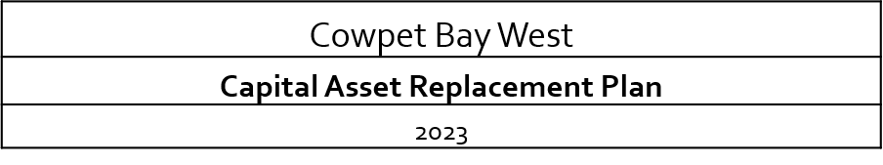
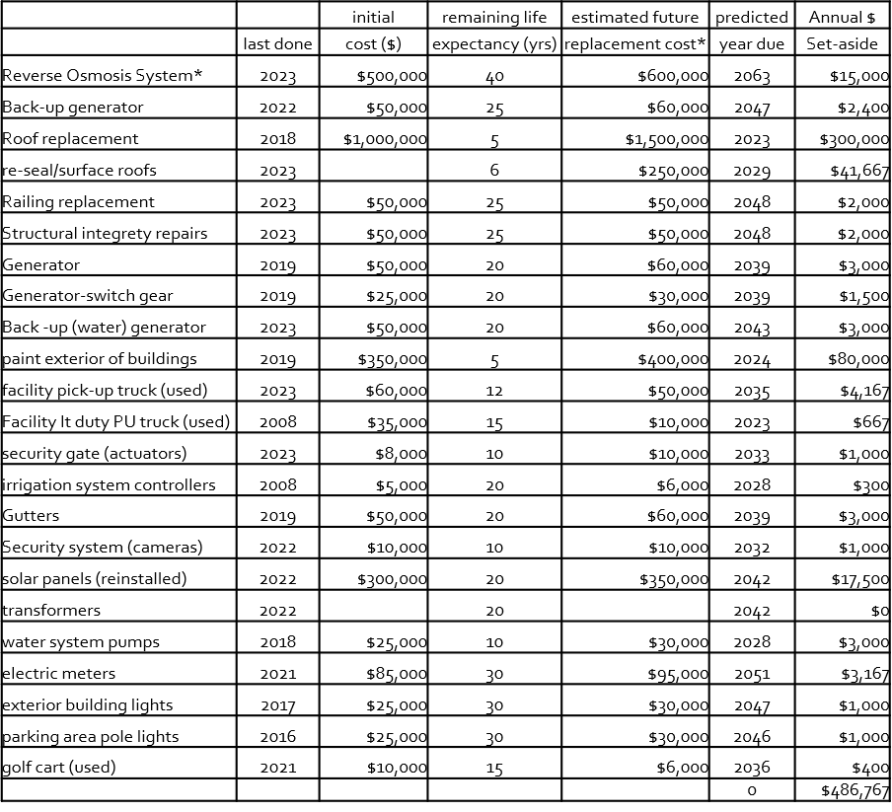

Treasurer’s Report: Kevin Gregory
Bank Balances
As of 2-9-2024
 |  |  |  | Fidelity
 |  | Banks |  | Funds* |  | total
payroll | Banco Pop | 5,700 |  | - |  | 5,700
operating | Banco Pop | 40,955 |  | - |  | 40,955
Insurance | Banco Pop | 3,328 |  | 535,799 |  | 539,127
Reserve | Merchants | 61,743 |  | 696,174 |  | 757,917
 |  | 111,727 |  | 1,231,973 |  | 1,343,700
* Fidelity Funds cash is invested in their Government
Money Market, symbol SPAXX.

Insurance Committee Report: Kevin Gregory
Last year, we conducted a thorough marketing of our property insurance (this policy alone accounts for 95% of our total insurance costs). The results of this effort were to save CBW over $100,000. Included in the new insurance structure was a carve-out of the value of foundations and cisterns from wind and flood coverage. We insure these parts of our building separately now. Because of the thorough marketing last year, we have decided to forgo that process this year. While other brokers will not be involved, Tunic will make inquires with other carriers to obtain the best renewal terms for us possible. We expect to conduct another thorough marketing effort, with competing brokers, on a three-year cycle. On the property policy, we expect the premium cost to increase in tandem with our “insurance replacement values”. This figure is up about 13%, which would increase our premiums by $85,000 to a new property premium of $737,890. We will work hard to minimize this. We expect our other policies to be renewed in 2024 without any material increases.

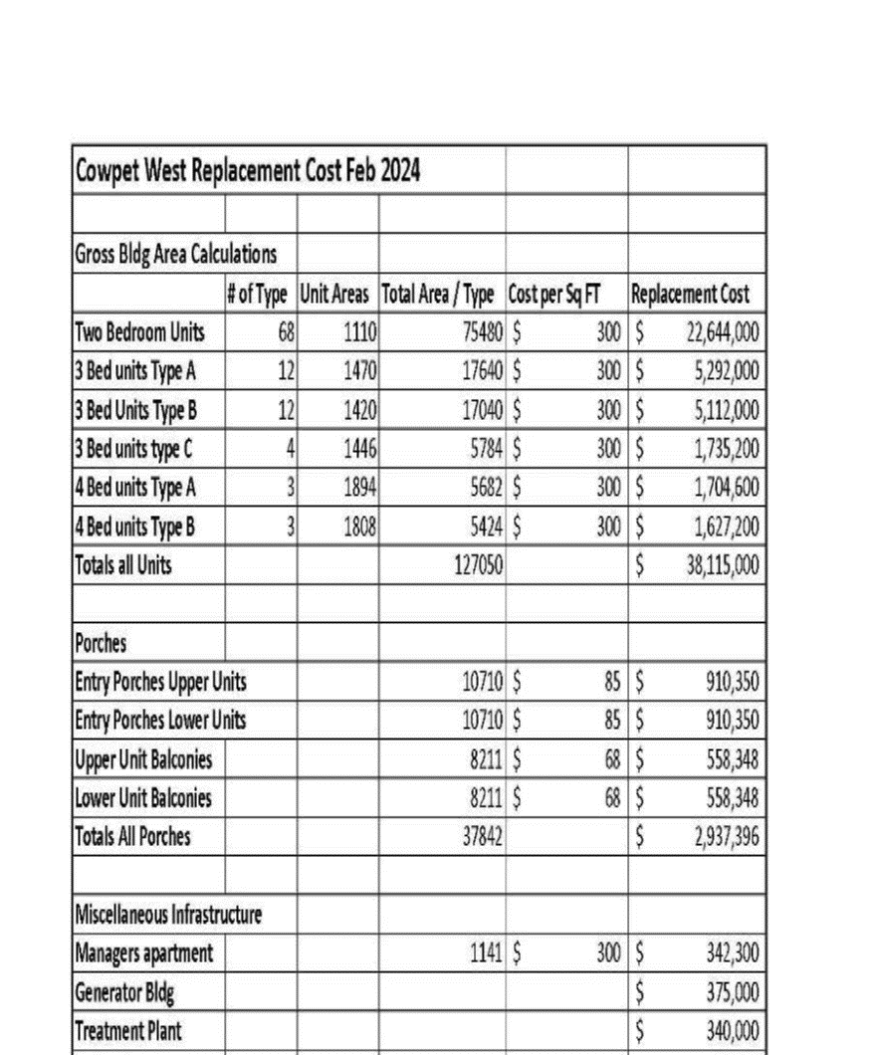

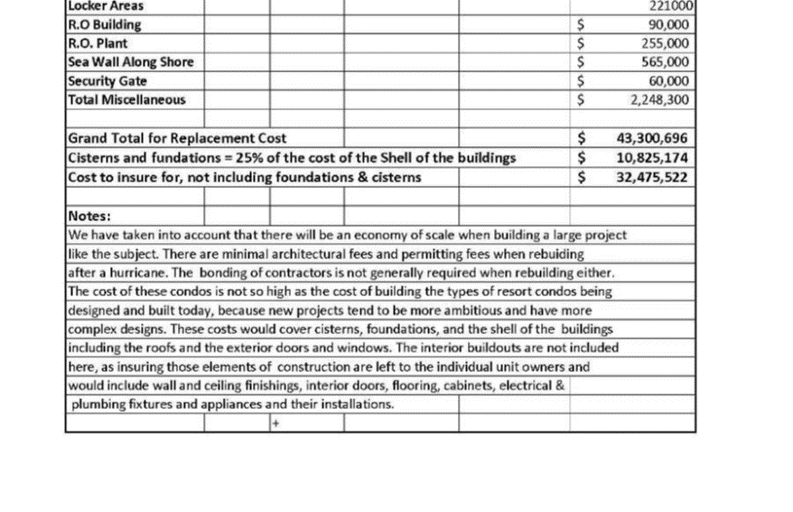
Directors & Officers Liability:
Broker: Tunick/AMWINS
Carrier: Lloyds
Form: Gt American
Limits $3,000,000
Deductible $ 10,000
Premium $ 13,568
General Liability:
Broker: Tunick
Carrier: Dorchester
Form: ISO Commercial CGL
Limits $5,000,000
Med Payments $ 25,000
Fire Legal Liability $ 100,000
Deductible $ 2,500
Premium $ 8,939
Auto:
Broker: Tunick
Carrier: State National
Form: ISO Commercial Auto
Limits $1,000,000
Un/under insured $ 20,000
Med Pay $ 5,000
Deductible (comp/coll) $ 500/1,000
Premium $ 10,572
Fidelity Bond:
Broker: Executive Insurance
Carrier: Traveler’s
Limits $ 500,000
Deductible $ 5,000
Premium $ 1,107
Workers Compensation: per Statutory limits & premium
Total all Premiums: $ 687,887
2024 CBW Budget
Income/Expense Item |  |  |  | 2022 Budget |  | 2023 Budget |  | 2023 Actual |  | Difference |  | 2024 Budget
 |  | Other Income
 |  | 4850 - Other Incomes |  | $1,500.00 |  | $0.00 |  | $43,756.30 |  | (43,756.30) |  | $0.00
 |  | Total Other Income |  | $3,000.00 |  | $0.00 |  | $43,756.30 |  | -$43,756.30 |  | $0.00
4000 |  | Income - Common Charges
 |  | Insurance Proceeds
4200 |  | Total Common Charges |  | $1,665,443.04 |  | $1,962,029.00 |  | 2,063,975.39 |  | (101,946.39) |  | $1,953,868.00
4300 |  | Utility Charges
 |  | Total Utility Charges |  | $550,000.00 |  | $620,000.00 |  | 573,956.26 |  | 22,622.61 |  | $615,000.00
4400 |  | Other Charges
 |  | Total Common Charges |  | $5,000.00 |  | $5,000.00 |  | $3,883.40 |  | 2,616.60 |  | $4,500.00
4500 |  | Interest & Dividends
 |  | Total Interest & Dividends |  | $500.00 |  | $11,500.00 |  | $44,416.30 |  | (32,916.30) |  | $50,000.00
TOTAL 4000 - Income |  |  |  | $1,749,100.00 |  | $2,598,529.00 |  | $87,894.52 |  | -$153,379.78 |  | $2,623,368.00
 |  |  |  |  | 2022 Actual |  | 2023 Budget |  | 2023 Actual |  | Difference |  | 2024 Budget
 |  |  | Income: 4200-4 - Reserve Fund |  |  |  | $328,003.08 |  |  |  | 0.00 |  | $ 328,003.08
 | 8100-1 |  | Capital Improvement Fund
 | Assessment |  | Electrical - Windward/Leeward-meter bases |  | $84,192.20 |  | $0.00 |  |  |  | 0.00 |  | $ -
 | Assessment |  | WWTP |  | $28,140.00 |  | $130,000.00 |  | $ 130,000.00 |  | 0.00 |  | $ -
 | 8103 |  | 6 meter bases |  |  |  | $25,000.00 |  |  |  |  |  | $ -
 |  |  | 3 phase electric update for generators |  |  |  | 20000 |  |  |  |  |  | $ 20,000.00
 |  |  | Windward/Leeward Painting |  | $0.00 |  | $100,000.00 |  |  |  | 100,000.00 |  | $ 75,000.00
 |  |  | Fence-repair |  | $0.00 |  | $15,000.00 |  |  |  | 15,000.00 |  | $ -
 | 8122.16 |  | Railing Repairs |  | $1,463.78 |  | $10,000.00 |  |  |  | 10,000.00 |  | $ 25,000.00
 | 8119.9 |  | Stair /Landing Repairs |  | $2,665.55 |  | $10,000.00 |  |  |  | 10,000.00 |  | $ 35,000.00
 |  |  | 8109- Security Gate |  | $7,580.00 |  | $5,000.00 |  |  |  | 5,000.00 |  | $ 5,000.00
 | 8110.1 |  | Security Lights-front enterance |  | $64.00 |  | $2,500.00 |  |  |  | 2,500.00 |  | $ 2,500.00
 |  |  | Dump Trailer |  |  |  | $0.00 |  |  |  |  |  | $ 10,000.00
 |  |  | Golf Cart |  |  |  | $8,000.00 |  |  |  |  |  | $ -
 |  |  | 2 Phillips Defibillators |  |  |  | $3,000.00 |  | $ 4,227.35 |  |  |  | $ -
 |  |  | Defibillator Cabinets |  |  |  | $300.00 |  |  |  |  |  | $ 1,300.00
 |  |  | 6 Fire Extinguishers, 10 pounds |  |  |  | $600.00 |  | $ 3,216.00 |  |  |  | $ -
 |  |  |  |  |  |  |  |  |  |  |  |  | $ -
 |  |  | Solar |  |  |  |  |  |  |  |  |  | $ 25,000.00
 |  |  | Structure Reinforce |  | $111,807.42 |  | $80,000.00 |  | $ 111,807.42 |  | (31,807.42) |  | $ 10,000.00
 |  |  | 8100-1 - Capital Improvement TOTAL |  | $4,129.33 |  | $275,000.00 |  | $ - |  | $142,500.00 |  | $ 208,800.00
 | TOTAL EXPENSE w/Capital Improvement |  |  |  | #REF! |  |  |  | #REF! |  | #REF! |  | $ 3,114,766.00

 |  | 2022 Actual | 2023 Budget | 2023 Actual | Difference | 2024 Budget
 | Income: 4200-4 - Reserve Fund |  | $328,003.08 |  | 0.00 | $ 328,003.08
8100-1 | Capital Improvement Fund
Assessment | Electrical - Windward/Leeward-meter bases | $84,192.20 | $0.00 |  | 0.00 | $ -
Assessment | WWTP | $28,140.00 | $130,000.00 | $ 130,000.00 | 0.00 | $ -
8103 | 6 meter bases |  | $25,000.00 |  |  | $ -
 | 3 phase electric update for generators |  | 20000 |  |  | $ 20,000.00
 | Windward/Leeward Painting | $0.00 | $100,000.00 |  | 100,000.00 | $ 75,000.00
 | Fence-repair | $0.00 | $15,000.00 |  | 15,000.00 | $ -
8122.16 | Railing Repairs | $1,463.78 | $10,000.00 |  | 10,000.00 | $ 25,000.00
8119.9 | Stair /Landing Repairs | $2,665.55 | $10,000.00 |  | 10,000.00 | $ 35,000.00
 | 8109- Security Gate | $7,580.00 | $5,000.00 |  | 5,000.00 | $ 5,000.00
8110.1 | Security Lights-front enterance | $64.00 | $2,500.00 |  | 2,500.00 | $ 2,500.00
 | Dump Trailer |  | $0.00 |  |  | $ 10,000.00
 | Golf Cart |  | $8,000.00 |  |  | $ -
 | 2 Phillips Defibillators |  | $3,000.00 | $ 4,227.35 |  | $ -
 | Defibillator Cabinets |  | $300.00 |  |  | $ 1,300.00
 | 6 Fire Extinguishers, 10 pounds |  | $600.00 | $ 3,216.00 |  | $ -
 |  |  |  |  |  | $ -
 | Solar |  |  |  |  | $ 25,000.00
 | Structure Reinforce | $111,807.42 | $80,000.00 | $ 111,807.42 | (31,807.42) | $ 10,000.00
 | 8100-1 - Capital Improvement TOTAL | $4,129.33 | $275,000.00 | $ - | $142,500.00 | $ 208,800.00
TOTAL EXPENSE w/Capital Improvement |  | #REF! |  | #REF! | #REF! | $ 3,114,766.00

Reserve Fund: Kevin Gregory
-As our Reserve Fund grew in 2023, we opened a Fidelity Funds account to invest in US Government Securities.
-While the SIPC limit of Insurance is 250,000, investing in US Government securities minimizes money market investment risk.
-The Reserve Fund is intended to fund unusual or unexpected expenses throughout the year
-Application of accounting rule ASC 606 on the 2022 Audited FS changed the nature of the reserve fund to a liability account.
-Under this new accounting rule, use of Reserve Funds to cover operating expenses creates an equity deficit.
-Goal: maintain $1,000,000 in Reserve Fund.
Break for questions.

New Business: Bill Hanson
Current Projects:
-WWTP Pump room remodel and new blowers installed
-a new drying tank has been installed at the WWTP
-a new aeration tank has been installed as well
-we still need to repair the old aeration tank which is cracked and needs work
-a new driveway and parking area for CBW vehicles was created at the WWTP
-several ongoing landscaping projects are occurring at the entrance and the STYC
-a new, safer path to the SSTYC was also created and the old stairs were condemned
-pictures were shown of all projects
2024 Action Items:
-Evaluate roof s – possible repair or replacement
-Consider restructure of landscaping staff
-Vehicle replacements & additions including trailer
-Vote on Merger Document
-Vote on Amended Bylaws
-Complete Solar Panel installation
-Continue building structural repairs as necessary
-Begin new cistern cleaning schedule
-Optimize use of all cisterns on the property
-Purchase storage container for equipment storage
-Install new access doors for basements
-Further expand basement ventilation
Bring new Waste-Water Treatment tank online
-New Reverse Osmosis plant – grant funding
-Continued repair of building structural issues
-Auxiliary parking area for excess vehicles
-Upgrade Leeward irrigation system (WiFi)
-Connect new RO to Back-up generator
-Possible replacement of main entrance gate
-Continue replacement of railings and stairs to units as needed
-Rebuild cistern viewing port access ramps
-Rebuild enclosure for primary generator
-Post new Employee Handbook (once approved)
Old Business:
2023 Association Initiatives
-Amend 2023 ByLaws - (Advisory Committee, CBW BoD & attorney)
-Validate 1974 Merger document (CBW attorney)
-Refine percent ownership for stages (CBW attorney)
-Property Survey completed
-Update Employee Manual (Advisory Committee & Employment Law Attorney)
-Update CBW Rules and Regulations (Advisory Committee & CBW attorney)
-Coastal Zone Management Master Permit applied for
-Water Consumption-average 2 bedroom use in Jan 2024 was 2050 gal/month
-January 2024 94,886 gal
-February 2024 199,832 gal
-46% of our units use 74% of our water
-Greater water usage burdens our WWTP
-Greater water usage increases our common power consumption
-Considering water conservation measures – two-tiered rate structure
 | - base rate | - high rate
- gallons | - $0.10 | - $0.15 | - total
- 2050 | - $205.00 | - $0.00 | - $205.00
- 2500 | - $205.00 | - $67.50 | - $272.50
- 3000 | - $205.00 | - $142.50 | - $347.50
- 3500 | - $205.00 | - $217.50 | - $422.50
- 4000 | - $205.00 | - $292.50 | - $497.50
- 4500 | - $205.00 | - $367.50 | - $572.50
- 5000 | - $205.00 | - $442.50 | - $647.50

Power Consumption & Conservation:
-20% increase related to water consumption
-Potable-water and waste-water processing accounts for much of association’s power use
-New more efficient WWTP pumps & blower installed
-New more efficient RO plant planned
WAPA Billing Appeal: Richard Hunter
-In September 2019 WAPA’s meter for CBW showed electrical consumption of zero. The meter had failed and needed to be replaced
-No WAPA bill was sent to CBW until January 14, 2020, which apparently reflects WAPA’s field personnel presumably attempting to fix the meter or make some recalibration and back bill to cover the defective meter for the preceding months.
-The next bill CBW received was for March 24, 2020. This bill showed a meter charge of close to four times the normal usage.
-The April 24, 2020 bill reflects usage from two meter numbers – both the Old Meter and a New Meter which had been installed.
-In October 2020 WAPA applied a credit to CBW of $82,031.17.
-By our calculation (as well as pursuant to the formula set forth in 30 V.I.C. § 127(a)(1) and (b)), WAPA overbilled CBW by approximately $186,195.00. This figure takes into account the $82,031.17 credit in October 2020.
-Following a conference call between me, our retained counsel and WAPA’s in-house counsel, WAPA’s indicated that WAPA would be willing to give CBW a credit of $80,000.00. This is insufficient.
-CBW is requesting that WAPA either recalculate the usage and consumption figures pursuant to 30 V.I.C. § 127(a)(1) and (b) to determine a reasonable fee for CBW’s usage or credit CBW’s WAPA account with an additional $186,195.00.
-Due to the slow progress with WAPA, I have recommended to the Board that CBW file a Complaint with the Public Services Commission which is sympathetic to customer complaints, and then seek to resolve the matter by further negotiation.

Ongoing Projects:
Solar Panels:
-reinstallation still underway, 80% completed
-New cables and inverters installed
-New contractor (ProSolar) to finish job
-Back-up generator installed, new exhaust required to finish the job
-Generator to power gray water, possibly add RO
-Repair of back-up raw water line to WWTP
-Install tank monitors on all cisterns as safeguard
-Connect new aeration tank to WWT system & disconnect old aeration tank
-Tie new drying tank into WWT system
-Evaluate old tanks and get quotes for repair
-40kw Backup generator and automatic switch for graywater is now being installed
Q&A Session:
-Any questions or comments on reports or 2023 P&L and 2024 Budget?
-Provide motions or amendments through email to the CBW office
-Motions will be distributed for on-line voting by all owners
-Motions and amendments require a simple majority of owners
-Bylaw changes will require a 2/3 majority
-Merger Document requires ¾ majority
-Declaration changes require unanimous vote
-Kim Cole asked if we are benefitting from the solar panels- Matt states about $3000/month, with a potential of $6,000 when all are reinstalled.
-She also asked if metering is AMI- Matt confirms it is and we read the meters as well.
-Dave McDonough asked Kevin to explain the relationship between deficits and reserve fees.
-Kevin states that reserve funds cover deficits, and unexpected expenses come from the reserve. Kevin says he is not alarmed by the deficit.
-Dave asks if we should anticipate an increase in assessments to make up for the deficit?
-Kevin explains that our deficit indicates that our O&M fees are too low, and this is something the board will be looking at this year.
-Bill Hanson reiterates that we are not billing enough to cover our expenses and at some point we will need to raise our fees.
-Dave states that the maintenance and grounds and management are great and if we need to raise our fees to continue to see this level of work, we should.
-Marguerite Hefferon asks how much is the operating deficit?
-Sherri Levin states that the deficit comes from the accounting standard 606 being implemented.
-606 changes the way we record what we bring in so liabilities are increased and this effects the equity, thus we see a deficit.
Marguerite asks again, are we spending more than we are bringing in?
-Bill H says yes, but we have reserve funds for the needed Capital Improvements, and we simply can not ignore some projects which are safety concerns.
-Alan Eberhart asks about the proposed roof project, and wants to know what will be replaced since the roofs were just done 6 years ago.
-Bill H states that the roof structure(plywood and tape) is good for the most part, but the silicone that goes over it is bad, and the estimate to replace the coating seems high.
-Judi Kromenhoek states that we received 3 estimates-
1. 1 million to coat and will last only 3-5 years
2.1.6 million to redo roofs completely with a 20-year guarantee
3. 1.7 million to replace with metal roofs with a 20-30 year guarantee
-Marguerite asks how are we going to fund this project?
-Bill H states we have two obvious options, loan or special assessment, but he also points out that the Board has just begun to discuss this issue.
-Marguerite suggests that someone investigate a grant for the project.
-Bill Friend wants to know why the solar panels were put up before the roof was repaired.
-Bill H informs him that we repaired that portion of the roof prior to installing the panels.
-Kim Cole, Alan Eberhart, and Bill H discuss the possible tiered water system.
-Don Morrison thinks we should investigate alternatives to paying for security guards. He suggests electronic surveillance.
-Marilyn Blackhall states that condos with security and a gate have increased property values, and the security and the gate act as deterrents for crime. She asks how many cameras we have.
-Matt states that we have over 30 and are adding more. He explains that VIYA has been challenging and that we are speaking with ADM as well on options.
-Alan states that Marilyn has a good point, that security adds value, but he thinks we need security during the day as well because of past criminal activities that occurred during daylight, and he states that cameras do not prevent crime.
-Sherri states that the cameras work and helped her to identify a hit and run that occurred.
Bill Hanson asks if there are any more questions and if not, we invite owners to walk the property with us after the meeting to see the various things we discussed here today.
Election Results:
Four candidates ran for four positions on the board this year and the three with the most votes will serve three-year terms. Those (in order of most votes first) are George Hefferon, Judith Kromenhoek, and William Brewer. Tara McCafferty will serve a one-year term.
Meeting Adjourned:
-There being no further business, the meeting was adjourned at 11:30AM.

